The Effect of Density of the Liquid Medium Which an Object is Submerged in on the Buoyancy Experienced by the Object

`

Leo Chai

White Oaks Secondary School

# Table of Contents

Introduction 1

Theory 1

Archimedes’ Principle 1

Water Pressure Interpretation 1

Developing the Formula 1

Exploration 1

Hypothesis 1

Experiment 1

Material list 1

Procedure 1

Points of Caution 1

Analysis 1

Data Processing 1

Table 1: Weight of Aluminum weight (N) when placed into mediums of different densities (g/100ml) 1

Table 2: Buoyant force experienced by the aluminum weight when placed into mediums of different densities and uncertainties of measurements 1

Graph 1: Buoyant Force Experienced by the aluminum weight as force density of medium increases 1

Graph 2: Scaled Graph of buoyant force experienced by the aluminum weight as force density of medium increases 1

Trends and Reliability 1

Sources of Error 1

Variety of Data 1

Dissolution of different liquids 1

Conclusion 1

References 1

# Introduction

The buoyant force plays an essential role in our universe and can be observed everywhere in our daily lives. They are what keeps the massive cargo ship on the ocean afloat, which allows fish and submarines to control its vertical movement. (Challoner, 1997)

I am very interested in the battleships that have served in WW2, and I specifically find their large turret guns to be very cool. I have recently gotten the idea to create my model of the Japanese ship Nagato. (Yuji, 2006) However, several prototypes of the vessels have either sunken because they were too heavy or flipped because of a lack of stability.

Just like how buoyant force keeps cargo ships afloat, it is also the force that pushes model ships up adrift in the water. (Challoner) The reason why my ship has sunken or is unstable is that it is either experiencing too little or too much buoyancy. (TSI, 2019)

In order to precisely design a ship that is stable enough for motorized operation while staying afloat, I need to make an accurate prediction of the buoyant force. (Foyle, 2018) Therefore, I have decided to investigate the cause of buoyant forces and how they can be controlled.

## Theory

The research of buoyancy begun early in human history. As time progressed, people modified and improved their models to explain and describe the nature of the buoyant force. (Britannica, 2019)

### Archimedes’ Principle

Greek physicist Archimedes have started his investigation in this topic back in 250 BCE. In his work *On Floating Bodies*, Archimedes explains what happens when a solid “heavier” than a liquid is placed in a liquid, and what happens when as solid “lighter” than the liquid is placed within it.[1] Archimedes describes that when the “heavier” solid is situated in the liquid, it will sink to the bottom, whereas the “lighter” liquid will displace an amount of the fluid that adds up to its weight. (Heath, 2009)

The first part of this statement is prominent: in a circumstance where the solid is heavier than the fluid, the fluid under the solid will experience less gravitational force than the solid does. This causes the solid to use part of the energy generated by the force to move the liquid out of its way.

The second part of this statement is more complex, and a sample thought-experiment would make it much easier to understand: imagine a glass full of water, when a solid denser than the liquid is placed in it, some water will flood out as the solid sinks entirely into the water. The amount of water that floods out will have the same volume as the solid after it sinks completely. This is because there is no creation or destruction of mass, and thus the mass of this closed system is conserved, and the sum of the masses of the solid and the water remains the same.

According to Newton’s third law of motion states that for every force in nature, there is an equal and opposite reaction force. In this situation, there must be a force that pushes the water up against the force of gravity. (Julius, 2019) With the environment being stationary, the only explanation for the force pushing the water up is that it is the reaction force of the force pulling the solid to sink into the liquid. (Lumencandela, 2018)

Because of that, a force and its reaction force has the same magnitude; the upward buoyant force pushing the solid up the fluid is the same as the force of gravity pulling the liquid down. The magnitude of gravitational force acting on the liquid is the weight of the amount of liquid, which occupies the same volume as the solid submerged. (Khan Academy, 2015) This means that the buoyant force which an object experiences after being placed in a liquid is as same as the weight of the displaced fluid: since the displaced liquid was once filling out the space below the surface that is now occupied by the solid, the displaced liquid has the same mass as the solid. (Pickover, 2008)

This critical observation is known as the Archimedes’ Principle, and it remains an essential pillar to fluid mechanics to this day. (Trubin, 2018)

### C:\Users\The Leo\Pictures\Physics EE\forces.pngWater Pressure Interpretation

While the Archimedes’ Principal uses intuition to help explain the buoyant force which an object experiences, there is a more in-depth explanation of the occurrence of buoyant force.

Figure 1: Pressure experienced by any object in a liquid environment

On Earth, any environment filled with particles either with liquid or with gas will have pressure within it (Figure 1). The pressure is the force applied perpendicular to the surface of an object measured in per unit area. The internal pressure of these substances on Earth is caused by the gravitational pull on the weight of each particle, pulling them together towards the ground. (Victoria State Government, 2018)

The internal pressure within liquids and gas is also not constant. This is because the deeper the point of measurement, the more particles will be on top of the location of measurement. Since the force of gravity directly causes pressure, the particles on top will be pushing down, increasing the pressure as more particles are present above the point of measurement. (Khan Academy)

The internal pressure also acts in all directions. This is because when all the particles have a positive temperature measured in K, they are all moving randomly. The pressure measured at any given point in the environment is caused by the moving particles colliding with the surface of the measurement tool. Since the particles are all moving in random directions, the direction of force generated by the pressure will also be in all directions. (Hyper physics, 2018)

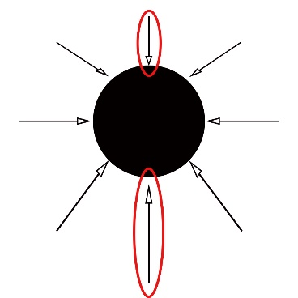 Since the pressure acts in all directions, the net force which it applies on a particular point cancels out, as the force it experiences from all directions is the same. However, when talking about something with actual dimensions, this assumption falls.

Figure 2: The top and bottom of an object experiences different magnitudes of pressure

While the forces acting perpendicular to the direction of gravity remains constant, as the weight of the particles above them are equally distributed on each particle, the forces acting parallel to the direction of gravity is different (Figure 2). This is because when an object is entirely placed within a uniform stationary liquid or gas environment, the top of the object will be positioned higher than the bottom of the object, thus causing the top and bottom to experience different magnitudes of forces due to pressure. (Hyper physics)

The bottom of the object would have more pressure since it has a further distance to the top, which means that the bottom will have more weight placed on it. Thus, it increases pressure. (NASA, 1996)

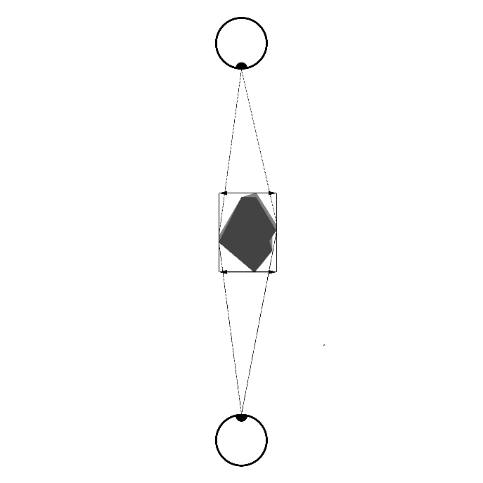

Figure 3: If a shape is observed from two opposite directions, the obeserver will observe shapes with same area.

The surface area of the top and bottom of any object is the same. This can be demonstrated through a thought experiment: imagine an object of any shape. When looking at it from the top, the shape observed will be the same as the shape observed when looking at it from the bottom. (Besant, 1889)

Since there is more pressure at the bottom of any given object contained in a liquid or gas environment, the bottom of the object will experience more force. Therefore, the pressure difference makes it so that the net force which the object experiences are upwards. (Pickover)

This upwards force caused by the pressure difference is the buoyant force. It also makes intuitive sense when explaining the Archimedes’ Principle. The upward force is caused by the pressure difference, which is precisely the amount of weight of the liquid taking in the place where the object is. Thus, the buoyant force is equal to the weight of the displaced liquid.

### Developing the Formula

In a resting fluid, the hydrostatic pressure is determined from the following formula:

(Besant)

$$p= ρgl+ p_{a}$$

Where:

* $P$ is the hydrostatic pressure ($Pa$)
* $ρ$ is the density of the medium surrounding the point of measurement ($kgm^{-3}$)
* $g$ is the gravitational acceleration ($ms^{-2}$)
* $l$ is the distance from the point of measurement to the top of the medium parallel to the direction of gravity ($m$)
* $p_{a}$ is the atmospheric pressure

Thus, the difference in pressure between the top and the bottom can be calculated by subtracting the distances:

(Besant)

$$∆p=p_{1}-p_{2} \\ =\left(ρgl_{1}+ p_{a}\right)-\left(ρgl_{2}+ p_{a}\right) \\ = ρg×\left(l_{1}-l_{2}\right) \\ =ρgh$$

Where:

* $l_{1}$ is the distance from the top of the object to the top of the medium parallel to the direction of gravity ($m)$
* $l_{2}$ is the distance from the bottom of the object to the top of the medium parallel to the direction of gravity ($m$)
* $h$ is the height of the object, which is also the distance between $l_{1}$ and $l_{2}$

Since buoyancy is the resultant force from the difference in pressure, it can be calculated using this formula:

(NASA)

$$F=pA \\ =ρghA \\ =ρgV \\ =mg$$

Where:

* $F$ is the buoyant force
* $A$ is the area that exerts the force due to the pressure. (base area)
* $V$ is the volume of the solid, simplified from $hA$ (volume = base area × height)
* $m$ is the mass of the medium displaced, simplified from $ρv$ (mass = density × volume)

This makes sense as the medium displaced would want to return to its equilibrium position, which is where the object is. Thus, the gravitation force acting on the medium will be transferred to the buoyant force, trying to push the object away in an attempt to restore its equilibrium.

Therefore, the formula for calculating the buoyant force which an object experiences, when placed in a liquid, is $F=mg$. However, since the mass of the medium displaced is hard to measure directly, $F =ρgV$ will be more useful for finding the buoyant force in real-life scenarios.

# Exploration

## Hypothesis

If the density of the medium is increased then the force due to gravity acting on the weight will decrease, because with a higher density but with the weight having a constant volume, more weight of the medium is displaced due to the weight, thus decreasing the force acting on the weight.

## Experiment

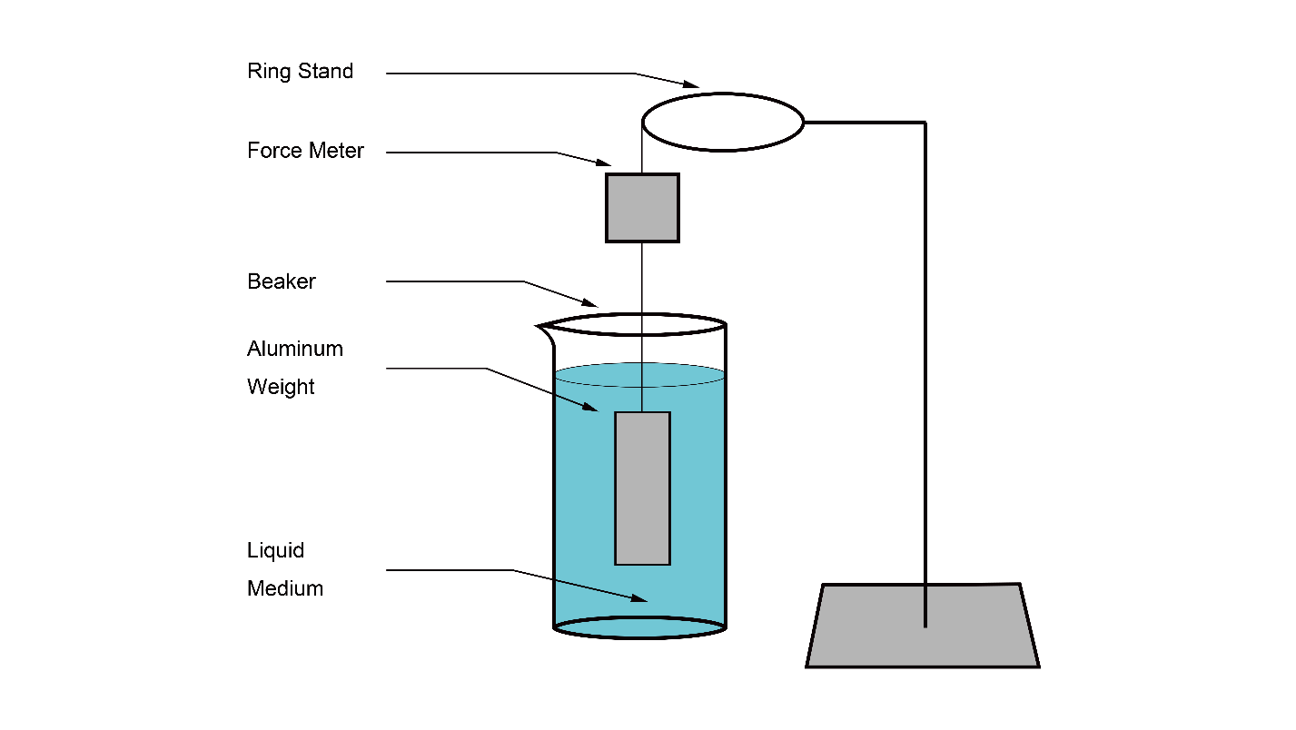

Note: The liquid medium will be changed to different solutions of different densities. For instance, sugar water solution and alcohol.

### Material list

Graduated cylinder(100ml) - 1

Electronic scale - 1

Glycerine – 300ml

Tap water – 300ml

Methyl – 300ml

Ring Stand - 1

Ring Clamp - 1

Force Meter - 1

String (25cm) - 1

Aluminum weight (0.07kg) - 1

Beaker (250ml) - 3

### Procedure

Methy has a density of 786.5 kgm-3, water has a density of 1000kgm-3, and glycerine has a density of 1259 kgm-3. The range was limited by material that was available to me. In order to get more smaple points, I can obtain a liquid with a density of around 900 and 110 kgm-3 by mixing the different liquids I have available. I did this by mixing 120ml of glycerine with 80 ml of tap water to create solution A and 70ml of methyl with 130 ml of tap water to create solution B. This was done with the use of the graduated cylinder and beakers.

For greater accuracy, I measured the density of each solution by weighing a 100ml sample of it on an electronic scale with a graduated cylinder.

I then set up the apparatus as shown in the diagram, and replaced the liquid medium with glycerine, tap water, methyl, solution A and B. 5 Trials were performed with each medium, with 100 ml of the liquid medium used for each trial. The same set of solutions were used for all of the trials, as the amount of material only allows such amount.

### Points of Caution

#### Measuring device

I used an out-dated force meter to measure the buoyant force, which lacked in accuracy and precision. I tried to calibrate the force meter using its calibration function. However, even after calibrating the device, the reading I have received a fluctuating reading on the last decimal place on the meter. I have tried to balance this out by increasing the uncertainty of the force measured by ±0.005N, since fluctuation on the last digit means that there is 0.01N uncertainty in total.

#### Mixing of different liquid mediums

When pouring and changing of liquid mediums, there might be some mixing of the mediums happening. While mixing in the container itself will not have a significant impact, since the amount mixed is so small that it would be negligible. There will also be some liquid that sticks on to the sides of the weight and is absorbed by the rope. The liquid sticking on the sides is a problem because this weight is added directly to the weight. It will increase the buoyant force of the new medium is denser than the previous medium or decrease the buoyancy if the new medium is less dense than the former medium, thus directly changing the results of the experiment.

To prevent the mixing of the liquid in effecting the results, I wash the containers and the weight involved after every trial with water, and wiped it clean with a paper towel. I have also used a paper towel to suck out all of the liquid in the rope to prevent the liquid in the string from adding any additional weight.

#### Deepness submerged

The buoyant force will be the same as the weight of the liquid of the same volume to the weight. Since the pressure in a liquid will increase as moving deeper, the deeper molecules will be packed together more closely. Therefore, the deeper liquid will have a higher density than the surface, meaning that the weight of liquid with the same volume as the aluminum weight will be heavier. Thus, the weight will experience a more buoyant force when at a deeper depth.

To make sure the weight is at the same depth for every trial, I filled the beaker containing the liquid with the same volume of liquid every time, and used the same rope to hang the aluminum weight to the force meter. I have also kept the ring clamp in the same place.

However, to maintain an extra level of caution, the height was adjusted so that the liquid barely covers the top. This is because, with the different densities of the liquid, the same amount of deepness can still result in a different amount of increase of buoyant force. By keeping the depth as shallow as possible, the change in force is kept as small as possible. While this should not make a difference in the results, I still did this as an extra level of caution.

# Analysis

After measuring the downward force acting on the aluminum weight, some calculation is required to see the relationship between the density of the liquid and the buoyant force experienced by the weight.

## Data Processing

### Table 1: Weight of Aluminum weight (N) when placed into mediums of different densities (g/100ml)

|  |  |  |  |  |  |  |  |
| --- | --- | --- | --- | --- | --- | --- | --- |
| Medium | Density | Trial 1 | Trial 2 | Trial 3 | Trial 4 | Trial 5 | Average |
| C3H8O3 | 122.62 | 0.301 | 0.298 | 0.307 | 0.294 | 0.303 | 0.301 |
| C3H8O3 + H2O | 112.31 | 0.319 | 0.330 | 0.315 | 0.326 | 0.322 | 0.322 |
| H2O | 97.95 | 0.377 | 0.369 | 0.365 | 0.376 | 0.378 | 0.373 |
| CH3OH + H2O | 90.71 | 0.383 | 0.387 | 0.395 | 0.392 | 0.385 | 0.388 |
| CH3OH | 77.60 | 0.421 | 0.425 | 0.418 | 0.413 | 0.427 | 0.421 |

Note: The Average is calculated by adding the values of trial 1 ~ 5 and dividing the sum by 5

$$w_{average}=(w_{1}+w_{2}+w_{3}+w_{4}+w_{5})÷5$$

### Table 2: Buoyant force experienced by the aluminum weight when placed into mediums of different densities and uncertainties of measurements

|  |  |  |  |  |  |
| --- | --- | --- | --- | --- | --- |
| Density  (N/100ml) | Weight  (N) | Buoyant force (N) | Density uncertainty | Weight uncertainty | Force Uncertainty |
| 1.203 | 0.301 | 0.312 | ±0.022 | ±0.012 | ±0.012 |
| 1.102 | 0.322 | 0.291 | ±0.021 | ±0.012 | ±0.012 |
| 0.9609 | 0.373 | 0.24 | ±0.020 | ±0.011 | ±0.011 |
| 0.8899 | 0.388 | 0.225 | ±0.019 | ±0.012 | ±0.012 |
| 0.7613 | 0.421 | 0.192 | ±0.018 | ±0.013 | ±0.013 |

Note: The uncertainties use the same unit as their parent unit

The force density (N/100ml) is calculated by multiplying the mass density by firstly dividing it by 100 to turn the units into kg/100ml, and then multiplying it by g to turn it into force density.

$$ρ_{F}=ρ_{M}÷1000×g$$

The buoyant force is calculated by subtracting the weight measured from the original weight of the aluminum weight (0.613N)

$$F_{B}=W_{O}-W_{M}=0.613 N- W_{M}$$

The Density uncertainty is determined by the smallest unit of measurement used to measure the weight and volume, and then adding them together as percentage uncertainty

$$u_{D}=u_{\%w}+u_{\%v}$$

The uncertainty of the weight and force is determined by finding the difference between the minimum, average, maximum, and taking the largest value to incorporate all of the values, and then adding it to the device uncertainty. However, the device showed fluctuation in the values when taking the readings, so I have added an extra 0.005 to the uncertainty to counter the fluctuation of the value on the force meter.

$$u_{W/F}=\max\left(u_{max}-u_{avg},u_{avg}-u_{min}\right)+0.005$$

### Graph 1: Buoyant Force Experienced by the aluminum weight as force density of medium increases

This graph is produced based on the measured buoyant force (table 2) and the hypothesized relationship between density and buoyant force. The line is generated with the formula that I predicted:

$$F =ρgV \\ =ρ×9.81×0.026 \\ =0.26ρ$$

### Graph 2: Scaled Graph of buoyant force experienced by the aluminum weight as force density of medium increases

This is a zoomed-in version of the previous graph on my data sets, as my line of best fit and a theoretical model is hard to differentiate on the last graph.

## Trends and Reliability

After plotting the results of the experiment on the graph, they show a direct linear relationship between the density of the medium and the buoyant force experienced since it intercepts the origin. By graphing the theoretical model with the line of best fit of the results, it can be seen that the line of best fit is very similar to the theoretical formula.

The results of the experiment have high accuracy. It has a very high r² value of 0.9817. The slope of the theoretical model is 0.26, the slope of the line of best fit of the experiment is 0.2564, and a large portion of this difference is due to significant digits. The similarity of the slopes shows that the data have high precision. Since the theoretical model fits within all of the uncertainties of the experiment, and it has high accuracy and precision, the results of the experiment are very reliable.

The results of the experiment show that as the density of the liquid increases, the buoyant force in which the weight experiences also increases. Experiments from other researchers also support the trend. When placing an egg in normal water, it sinks to the bottom of the container, but as salt is added to the water, the egg starts to float. (Tommy, 2007)

## Sources of Error

Before experimenting, I predicted some sources which may cause errors in the experiment. I took action in trying to minimalize the effects of these errors on the result of the experiment (see “Points of Caution”). However, I also noticed some additional sources of error that I have not expected.

### Variety of Data

The densities of the different liquid which I have used are very similar. The availability of materials causes this small difference. Having a little difference in samples means that the experiment might not create an accurate representation of trend, since it only makes up a small portion of the entire trend. Since I am thus forced to take measurements on a small scale, this would create higher relative uncertainty due to equipment limitations when compared to trials done with mediums with more significant density. Trends outside of the data range are also not observed, meaning there is a possibility that my hypothesis will not work for data that are significantly larger or smaller than my data set.

This can be improved by using lighter liquids or even gas, such as hydrocarbon. Higher density liquids such as mercury might not be appropriate, because they would create too much buoyant force, causing the aluminum weight to float above the surface. However, this can be fixed by connecting the weight to the bottom of the container. The pulling force will be measured from the tension of the connection between the weight and the container and adding the force of gravity to that.

### Dissolution of different liquids

In my experiment, I needed to mix different chemicals to create liquids with different densities. The various liquid I used to mix also have different viscosities. When I was mixing some of them, I have noticed that parts of the solution resisted my motion more than some other parts of the solution. This means that the solution is not mixed evenly, and thus the average density of the solution is different from the density of the solution at different points.

This might be caused by the solubility of the different liquids not being able to hold as much mass of each other as I have placed. It might also be because the liquid required more stirring to mix thoroughly. After doing some research on the solubilities of the different liquids, I have realized that the methyl is only 25% present soluble with water at room temperature.

A possible improvement is only to use chemicals that can thoroughly mix, or to use more chemicals with a smaller difference in density. This way, the density of the liquid will be even no matter the point of measure, and thus make the results of the experiment more accurate.

# Conclusion

The buoyant force has long played an important role in maintaining the world as it is as well as providing many conveniences to our daily life. The goal of this experiment is to find out more precisely the causes of the force, and how to accurately predict the force

Graph 1 graphs the experimental results along with the expected results from the hypothesized formula. The trend generated by the formula fits with-in the uncertainty range of the experimental results, and resembles the results of the experiment closely. It only has a 0.0012 difference in slope from the line of best fit generated from the experimental results.

After analyzing the trend and reliability of the results, it can be seen that the results of the experiment support my hypothesis. The buoyant force is caused by the difference in water pressure at different heights, and the magnitude of the force is the same as the weight of the displaced liquid.

This means that when I create my ship model, the weight of the water with the same volume of the parts of the ship underwater will be the buoyant force experienced by the ship. Therefore, the parts of the ship that will be underwater can be estimated by adding water to a hallow model of the boat. When the weight of the boat doubles, the top of the water will roughly resemble the place where water will reach.

Word Count: 3876

# References

Besant, W. H. (1889). *Elementary Hydrostatics.* Deighton: Deighton, Bell, and Company.

Britannica. (2019). Buoyancy. *Encyclopaedia Britannica*, 5.

Challoner, J. (1997). *Floating and Sinking.* Austin: Raintree Stech-Vaughn.

Foyle, J. (2018). Buoyant trade: model ships show histroy in the making. *Financial Times*, 14.

Heath, T. L. (2009). *On Loatin Bodies.* London: Cambridge University Press.

Hyper physics. (2018). Pressure. *hyperphysics*, 3. Retrieved from hyperphysics.

Julius, O. S. (2019). Newton's Three Laws of Motion. *CCRMA*, 1.

Khan Academy. (2015, July 23). Archimedes principle and buoyant force. *Khan Academy*. YouTube.

Lumencandela. (2018). Archimedes' Principle. *Lumen boundless Physics*, 8.

NASA. (1996). Buoyancy: Archimedes Principle. *NationalAeronautics and Space Administration*, 2.

Pickover, F. A. (2008). *Archimedes to Hawking.* oxford: Oxford University Press.

Tommy. (2007, Aug 13). *Tommy's Egg Float Project*. Retrieved from ggteks: http://www.ggteks.net/tommy/Eggproject.html

Trubin, J. (2018, Febuary). *Archimedes of Syarcuse*. Retrieved from juliantrubin: https://www.juliantrubin.com/bigten/archimedesprinciple.html

TSI. (2019). Transportation and Ship Design. *Exploring Our Fluid Earth*, 23.

Victoria State Government. (2018, September 05). *The particle theory*. Retrieved from Voctproa State Government Education and Traning: https://www.education.vic.gov.au/school/teachers/teachingresources/discipline/science/continuum/Pages/particletheory2.aspx

Yuji, K. (2006, Jul). *Battleship Nagato*. Retrieved from World War II Database: https://ww2db.com/ship_spec.php?ship_id=26

1. Back in the time of Archimedes, the concept of density has not been popularized. However, as Archimedes is investigating buoyant force, which is directly related to the density, he uses the words “lighter” and “heavier” to describe objects with less or more density.